April 2026
Hospital Auxiliary
P.O. Box 70
Lake Arrowhead, CA 92352

Auxiliary Officers
President:
Jeanne Hoy: (321) 626-7418
President-Elect:
Open
1st Vice-President:

(Membership)
Ronda Rynda: 744-9411
2nd Vice-President:
(Ways & Means)
Pat Jongerius: 336-0737
3rd Vice-President:
(Volunteer Coordinator)
Holly Carver: (951) 733-9898
Recording Secretary:
Galla Artiaga: 436-3209
Corresponding Secretary:
Jenni Mitchell: 641-1553
Nominating Chairperson:
Open:
Gift Shop Manager:
Lydia Hill: 744-8545
Parliamentarian:
Jeannie Venturini 337-7220
Treasurer (CFO):
Yvonne Waggener 436-3202

April Birthdays


3....….…...….Melissa Coates
19...............Hortencia Jurado
24………………Jaye Tarango

April Calendar

1….April Fool’s Day
2….Intl Fact Check Day
4….National Tell a Lie Day?!
10…Board Meeting @ 9:00
General Meetings @10:00
5….Easter Day
22.…National Volunteer
Recognition Day
22....National Jelly Bean Day
Mountains Community Hospital Auxiliary

Newsletter Editor: Holly Carver
E-mail: omas.guck@gmail.com

Flowers don’t worry
about how they’re going to bloom
They just open up
and turn toward the light
And that makes them beautiful
Jim Carrey

Letter from the President

Happy Easter Everyone!!

Our weather has been pretty interesting!! It truly felt like Spring/Summer for a few days and just like that, now it’s chilly and wintery feeling!! Who knows what tomorrow will bring?!?

Our Bake Sale on March 24th was very successful having an abundance of donated baked goods. We’ve also had some amazing days in the Gift Shop with phenomenal sales. Easter themed items and See’s candy have been flying out the door!

Pat, Christi and Lydia did an excellent job in preparing and selling the Easter Baskets this year…thank you to all who donated and helped prepare the baskets. We even had some Pet baskets this year! Thanks to Steff Miller for providing homemade doggie biscuits to include in those baskets.

Hope to see all of you at our next meeting on Friday, April 10th!! Blessings to All,

Jeanne Hoy, MCHA President
General Meeting at 10:00
on Friday, April 10th
in the George Medak Conference Room


New
Members

Suzanne Brothers
Spouse: Jonathan Jessop
P. O. Box 752
Twin Peaks, CA 92391
837 Deer Tree Trail
Crestline, CA 92325
Cell (714) 813-2377
Srb7796@gmail.com

Lanette Verdugo
P. O. Box 1605
Blue Jay, CA 92317
1230 Brentwood Drive
Lake Arrowhead, CA 92352
Cell (562) 242-4393
Verdugolanette76@yahoo.com


Hello

Happy
Spring(ish)!
It’s time to submit
your volunteer hours
for March,
broken down by “task”

Please send your hours to: jenimitch07@aol.com
Thanks everyone!
Jenni Mitchell, Hours Chair
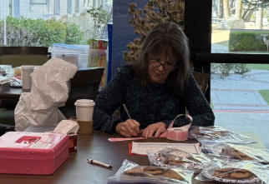
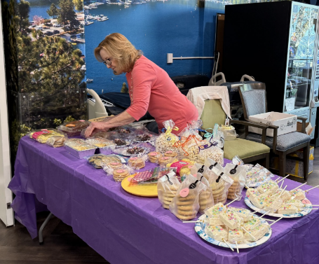
Spring was in the Air Bake Sale!

Thank you, once again, for the abundance of donated baked goods for the spring bake sale. Staff arrived well before “opening”, eyeing what they would purchase. In all, they purchased goodies totaling $452!!

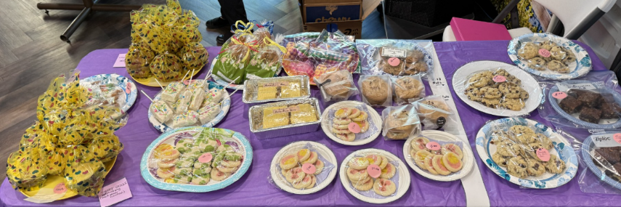

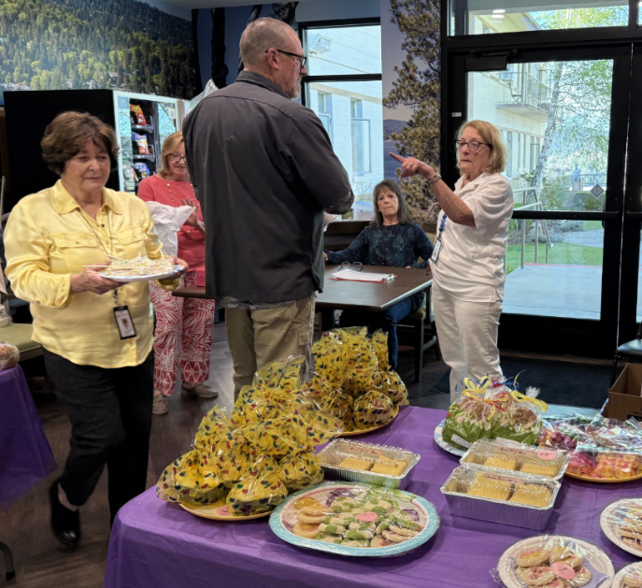
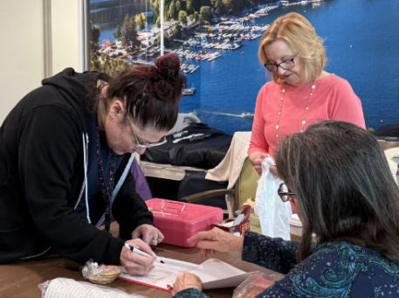
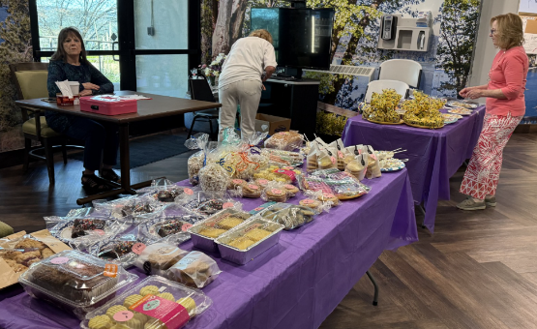
Can you put a caption to this photo?!? It looks like it must be some serious business, right?

Be sure to mark your calendars as you’ll have your next opportunity to bake for the bake sale on June 30th.
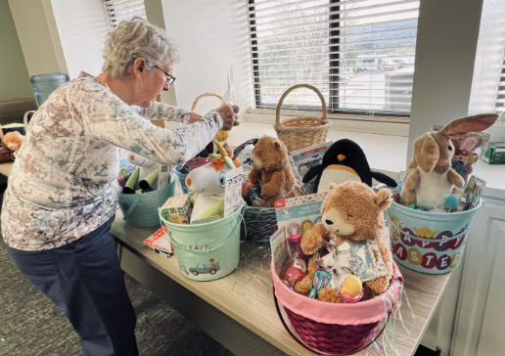
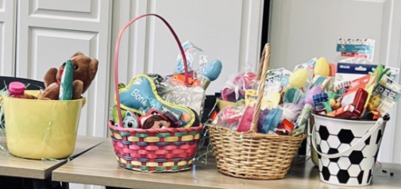
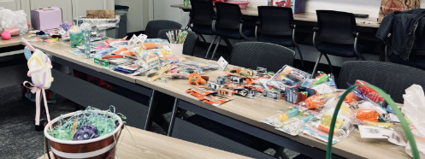
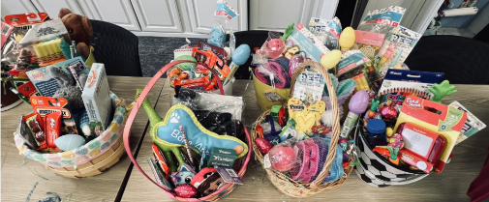


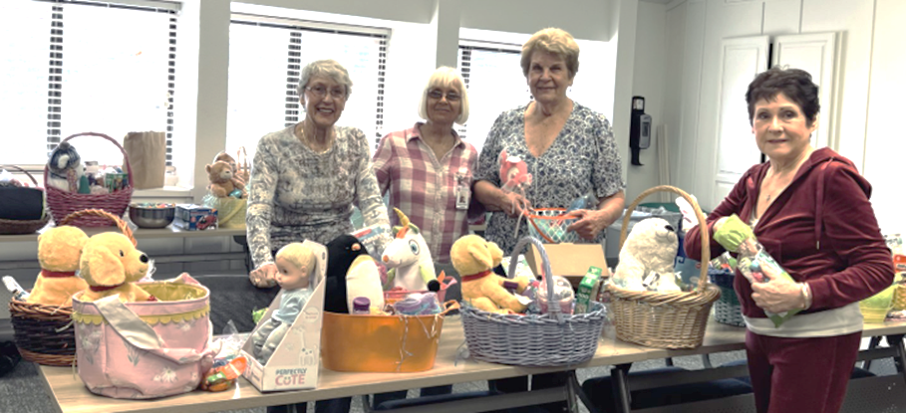
Easter Baskets for the Staff

The “Easter Bunnies”, Christi, Lydia, Pat, Toneya and Shannon (and Jack for bunny support!), would like to help all the “bunny helpers” for such generous donations of all kinds of candy, especially chocolate, and for a large variety of toys. The baskets were bulging with goodies and the staff were thrilled. We make 41 baskets with just a couple let to be sold in the Gift Shop. We will have a total sales figure at the next meeting.
Christi Schneider, Head Bunny
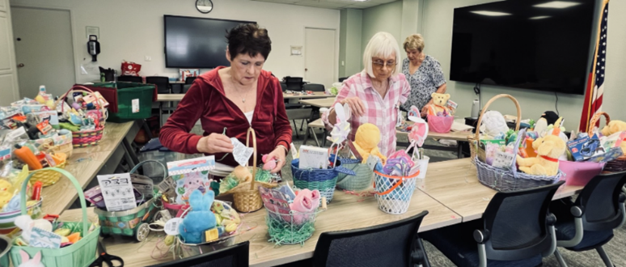
AKA Chairperson

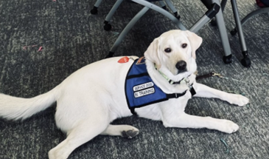
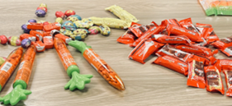

In the spring,
at the end of the day, you should smell
like dirt

Margaret Atwood

